

|  |  |  |  |  |
| --- | --- | --- | --- | --- |
|  | | | | |
|  | Milestone 2: Requirements Analysis (Project Requirements Template) | | |  |
|  |  | | |  |
|  | |  |  | |
|  | | John Keen johnkeenishere@gmail.com |  | |
|  | | January 14, 2023 —  Project Name:  Laptop Catalog —CST-451: Senior Project 1—Professor Brandon Bass —  Document Revision Number:  1 |  | |

# Abstract

This project is a laptop catalog and laptop e-commerce site. The original initiative was to create a web application that can Create, Read, Update and Delete the laptop records of an MSSQL database. Then the web application would make these records available to retailers by means of a REST API. The web application would need authentication to ensure that records could not be falsified and that the company does not suffer from the loss of reputation as the consequence of a malicious attack. A Laptop Manager would need a LaptopManager role in order to be authorized to access the area of the site with CRUD functionality once they are authenticated.

For this reason, a Manager role was created that allows a manager to create, assign or unassign roles. This management area of the site consists of four pages, Manage Roles (UI9), Create Role (UI10), Manage Users Roles (UI11) and Manage Roles (UI12). The Manage Roles can be used to view all of the roles and delete one if necessary. The Create Role is solely for the purpose of creating a new role. The Manage user’s roles allows the Manager to search for a particular user and then click on the Manage Roles link. That will take the manager to the Manage Roles page which can be used to add or delete roles for the user. The Manager has links to these areas available inside their Microsoft Identity profile area in addition to the standard functionality of the profile area. Registered users do not need a role in order to access the shopping area of the site.

The shopping area is where users can search for laptops, see the details of a laptop, add a laptop to their cart or navigate to their cart. The cart page allows users to increase or decrease the quantity for an item in their cart. Once the user is done shopping, they can check out. Only the last four of the user’s credit card is stored on the company’s site and it will be encrypted at rest. The user is provided with a receipt for their purchase.

|  |  |  |
| --- | --- | --- |
|  |  |  |

# Table Of Contents

Cover Page i

Abstract ii

Table Of Contents iii

Functional Requirements 1

Non-Functional Requirements 4

System Design 5

Technical Requirements 6

System Logical Model 7

User Interface Design 8

Reports Design 26

Security 27

# Functional Requirements

|  |
| --- |
| **User Story** |
| As a user, I would like to be able to register a new account so that I can login. |
| As a user, I would to be able to login so that I can access the features of the website. |
| As a user, I would like to be able to logout so that I can protect data that may be vital to me or my company. |
| As a Laptop Manger, I would like to be able to switch between a table view and a card view so that I can easily find what I am looking for and ensure that the information and image for the laptop is correct. |
| As a Laptop Manager, I would like to be able to search for laptops so that I can quickly find a laptop that needs to be edited or deleted. |
| As a Laptop Manger, I would like to be able to click a button that loads a create form so that I can create a laptop entry in the catalog. |
| As a Laptop Manager, I would like to be able to click a button that loads an edit form so that I can quickly edit a laptop entry. |
| As a Laptop Manager, I would like to be able to click a delete button so that I can delete a laptop entry. |
| As a Laptop Manager, I would like to be able to click a details button so that I can navigate to a page with the full details and full description for a laptop entry. |
| As a Laptop Manager, I would like to be able to see the same search results while switching between table and card view so that I can readily find the information I am looking for. |
| As a Manager, I would like to be able to register a new user so that I can get an employee started. |
| As a Manager, I would like to be able to create or delete user roles so that I can add roles for new pages that require authorization for a particular role or remove roles that were only needed for pages that have been removed from the web application. |
| As a Manager, I would like to be able to assign or unassign roles for a user so that I can manage who has access to particular features of the site. |
| As a Manager, I would like to be able to search for users so that I can quickly find a particular user. |
| As a retailer, I would like to be able to consume a REST API so that I can display the manufacturers data on my website. |
| As a Customer, I would like to be able search for a particular laptop so that I can find a laptop of interest. |
| As a Customer, I would like to be able to click a button that navigates to a full details page of a laptop entry so that I can learn more about a particular laptop. |
| As a Customer, I would like to be able to add an item to the cart from the products page so that I can add more than one item to the cart. |
| As a Customer, I would like to see the items in my cart so that I can know what I am purchasing. |
| As a Customer, I would like to be able to add or remove items in the cart so that I can manage what I am purchasing without having to navigate to a previous page. |
| As a Customer, I would like to be able to checkout so that I can complete my order |

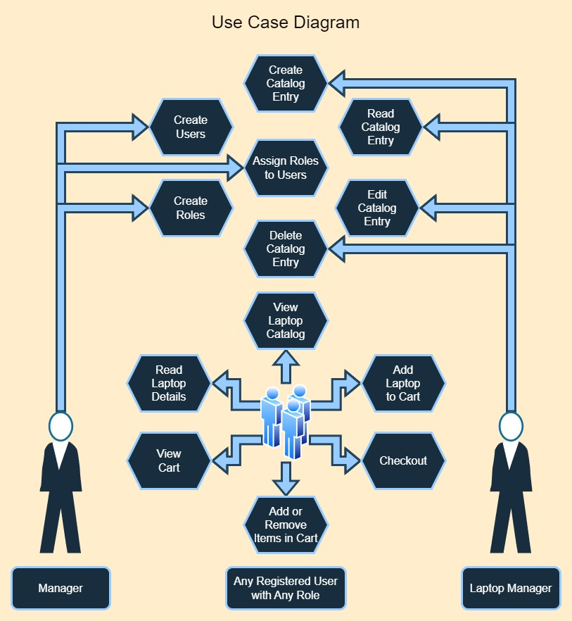

# Non-Functional Requirements

|  |
| --- |
| **User Story** |
| As a product owner, I will want to host this web application in the cloud so that the application is scalable. |
| As a user, I would like my password to be encrypted at rest so that I know my password is secure. |
| As a manager, I would like to authorize access to particular parts of the site based on roles so that I can minimize my attack profile. |
| As a user, I would like the website to have an uptime of 99.9% to ensure that it is available when I would like to make a purchase |
| As a user, I want the web application to load within 3 seconds to ensure an efficient browsing experience. |
| As a retailer, I would like the response time of the REST API to be under 1 second to ensure quick access to product information. |
| As a system administrator, I would like the platform to be able to handle 10,000 simultaneous users without a significant decrease in performance in order to continue to serve the needs of the customers. |
| As a user, I would like my vital information encrypted at checkout so that the security of my data is ensured. |
| As a product owner, I want the REST API to only provide information regarding available laptops and not allow creating, reading or updating functionality so that I can offer the REST API without the need for authentication. |
| As a retailer, I want the REST API to be simple to allow easy integration into my website. |
| As a developer, I want the code to follow the industry’s best practice so that I can ensure that the system is maintainable. |
| As a product owner, I want the hosting and platform to conform to relevant data protection regulations (Such as PCI DSS, GDPR, etc…) so that I can continue to operate as a business. |

# System Design

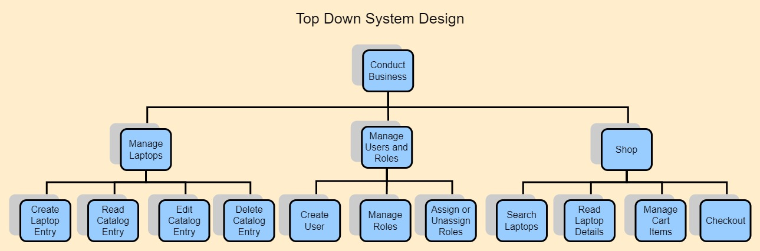

# Technical Requirements

**Use Cases**

Tools and technologies used in the project.

|  |  |  |
| --- | --- | --- |
| **Technology or Tool** | **Approval Date** | **Justification** |
| ASP.NET Core MVC |  | This will serve as the core architecture of the application. |
| Bootstrap |  | This will provide developers with the ability to quickly style. The bootstrap modal will be used for the Create page (UI6) and the Edit page (UI7). An ASP.NET Core MVC application comes with Bootstrap by default. |
| jQuery |  | This will be used to asynchronously post data to a controller and provide partial page refreshes by updating part of the view with a partial view. I am primarily interested in the use of Ajax with jQuery. |
| Stripe |  | This is not required but may be included to demonstrate how this web application could potentially use a payment gateway to accept a payment. |
| Identity Framework |  | This will be the main method of authentication. This will be used to ensure that certain controllers and actions are only accessible to users that have a role that is authorized. |
| Microsoft’s IDataProtectionProvider |  | This will be used to encrypt the last four digits of a customer’s credit card number so that the number is encrypted at rest. |

# System Logical Model

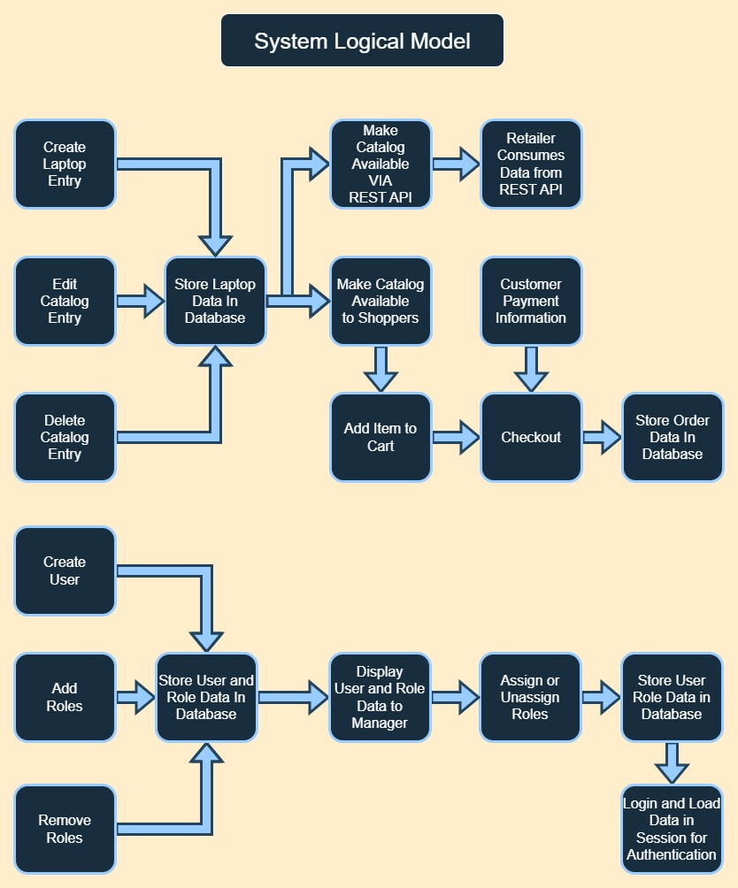

# User Interface Design

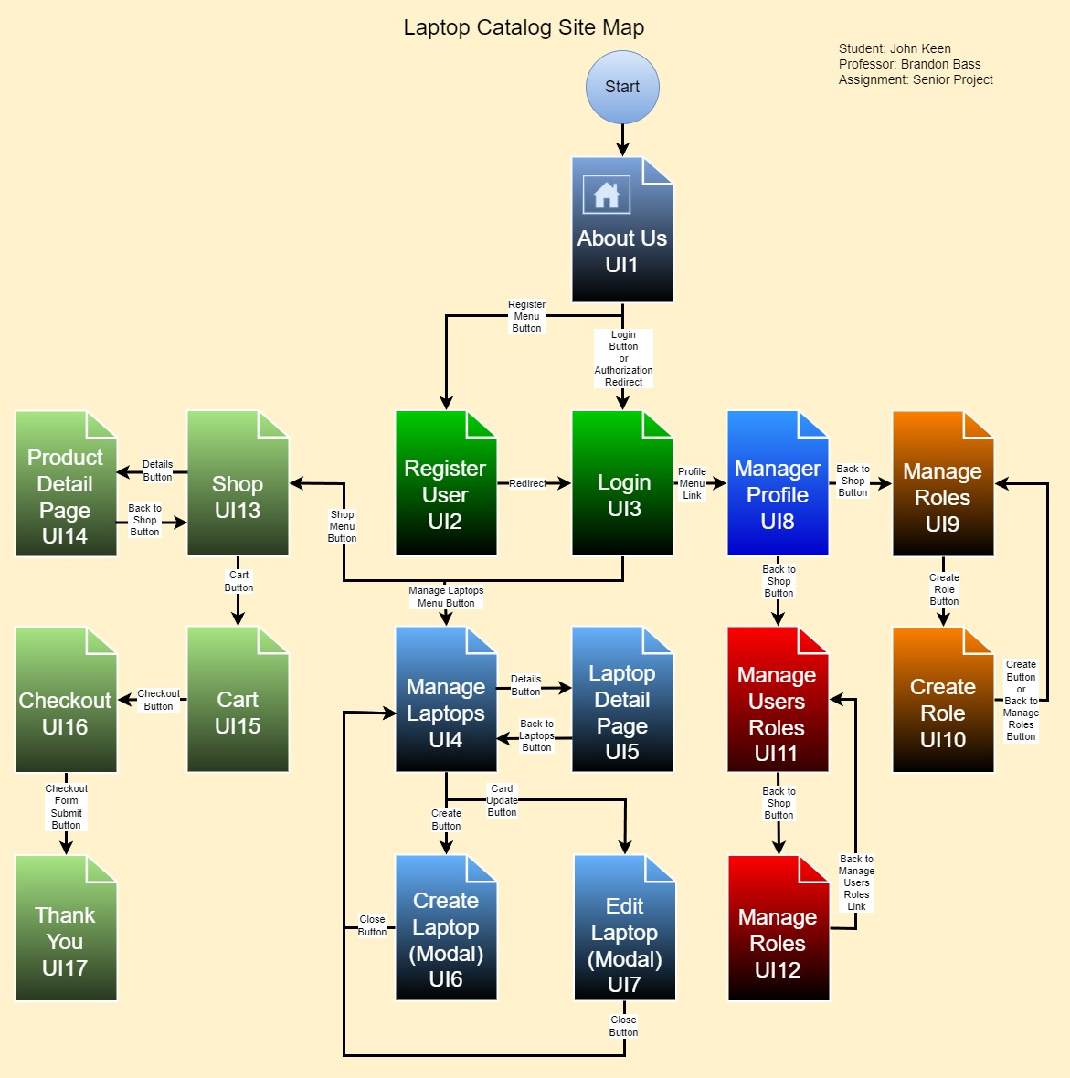

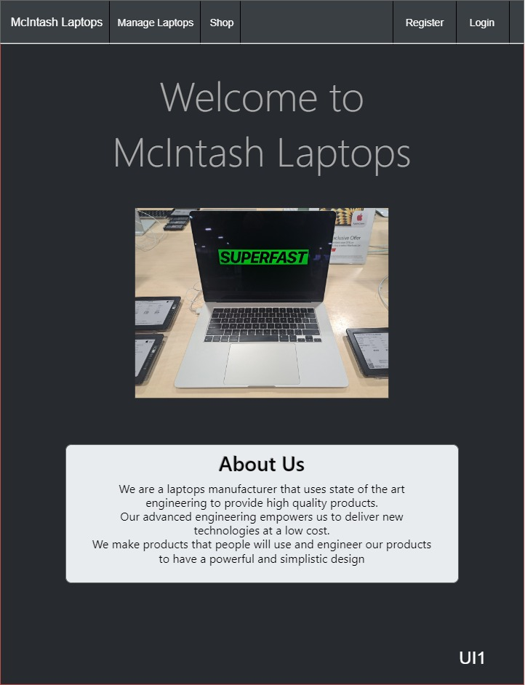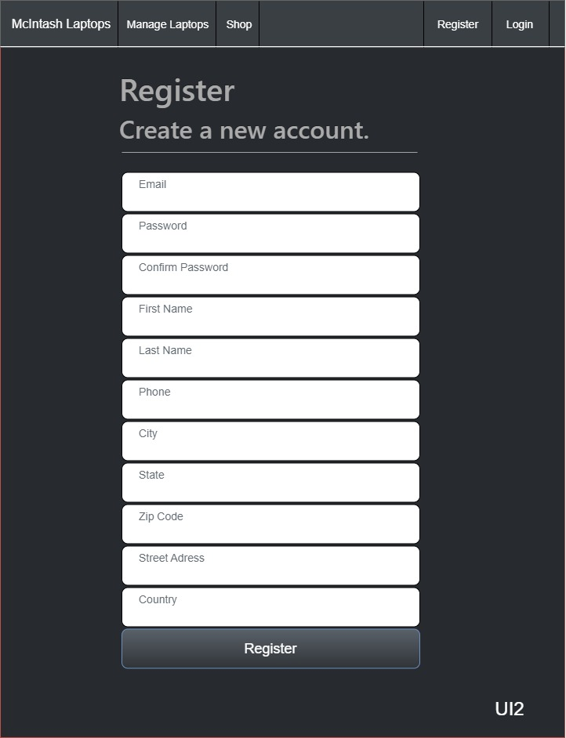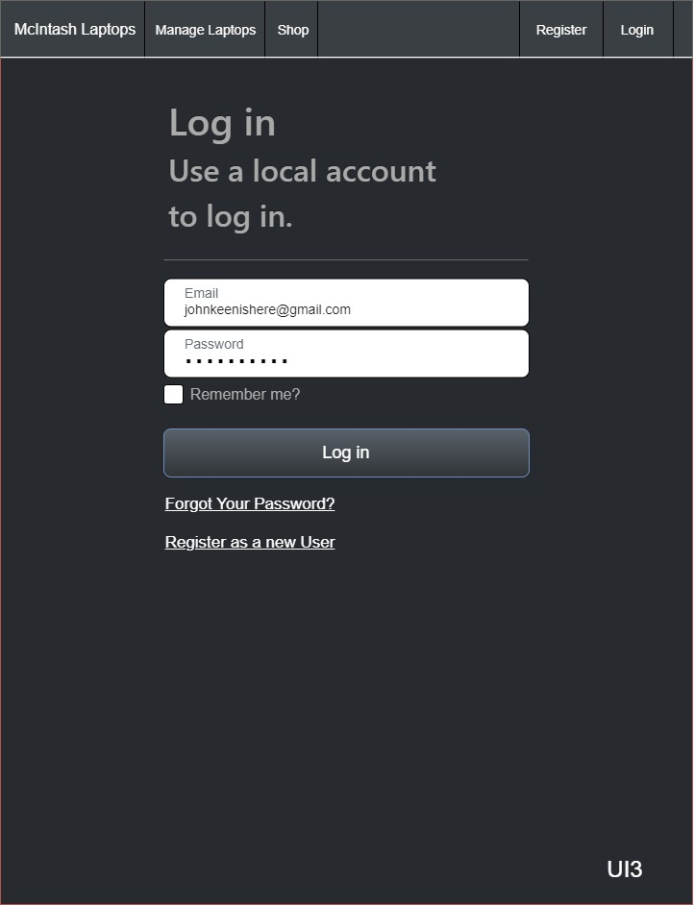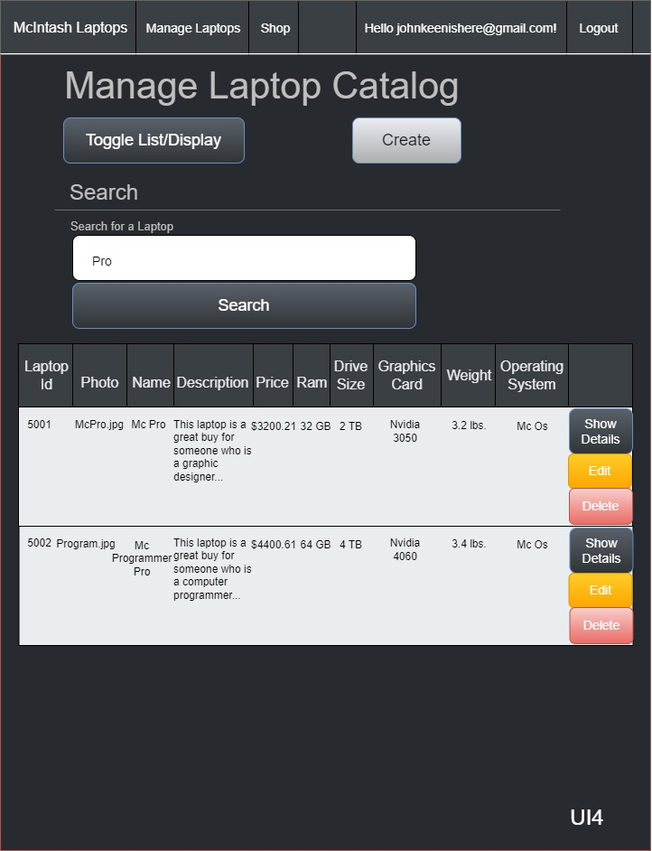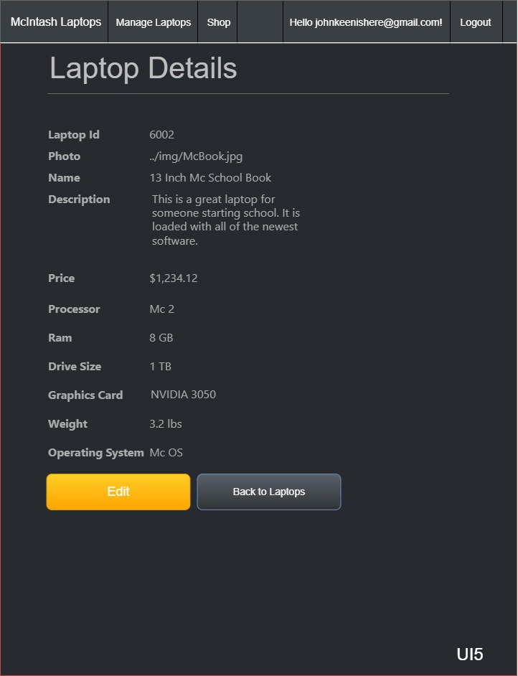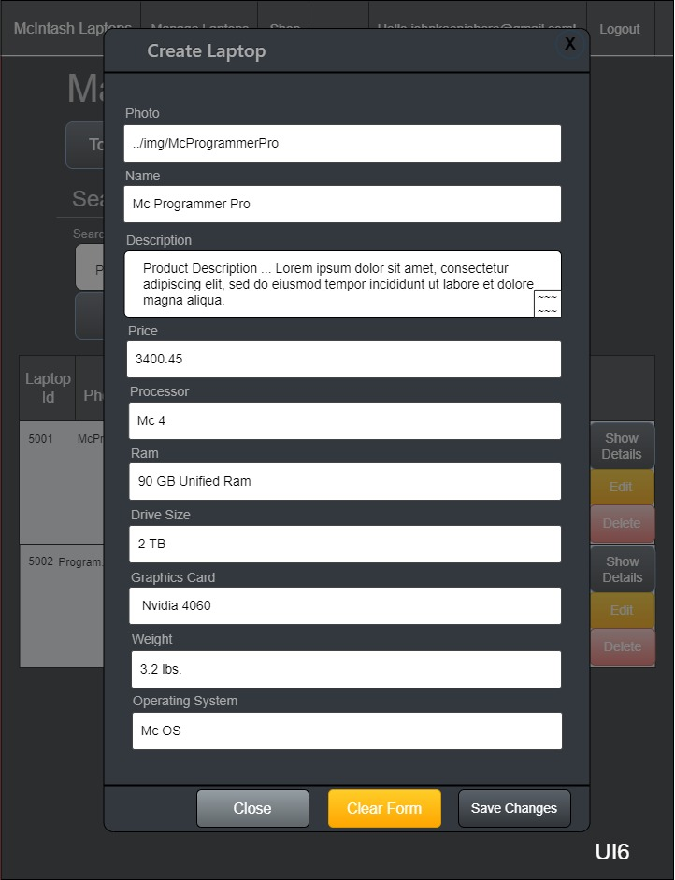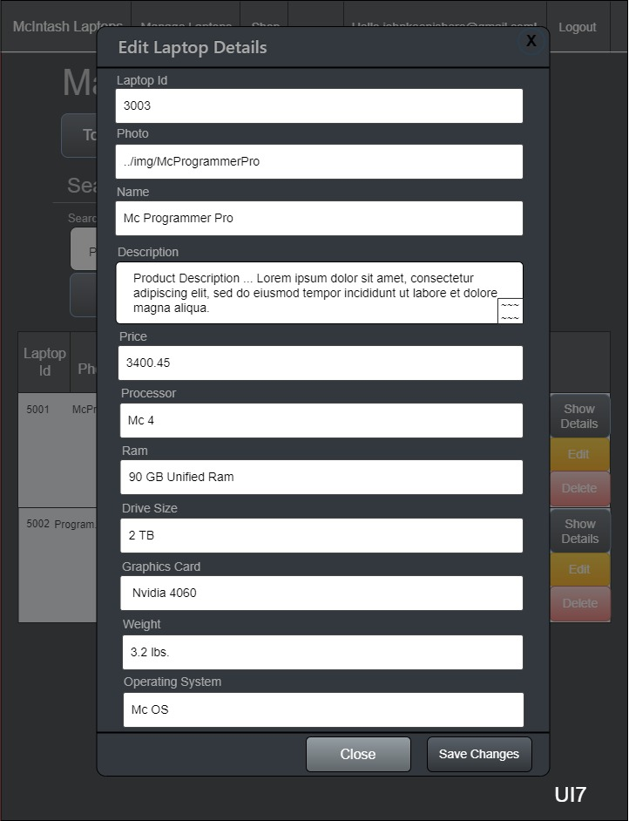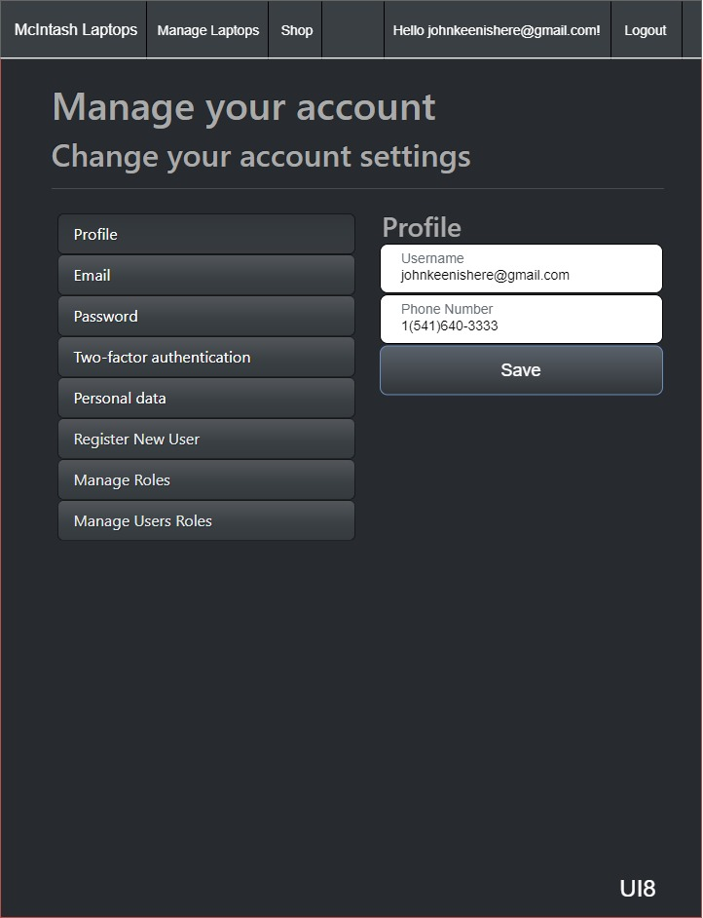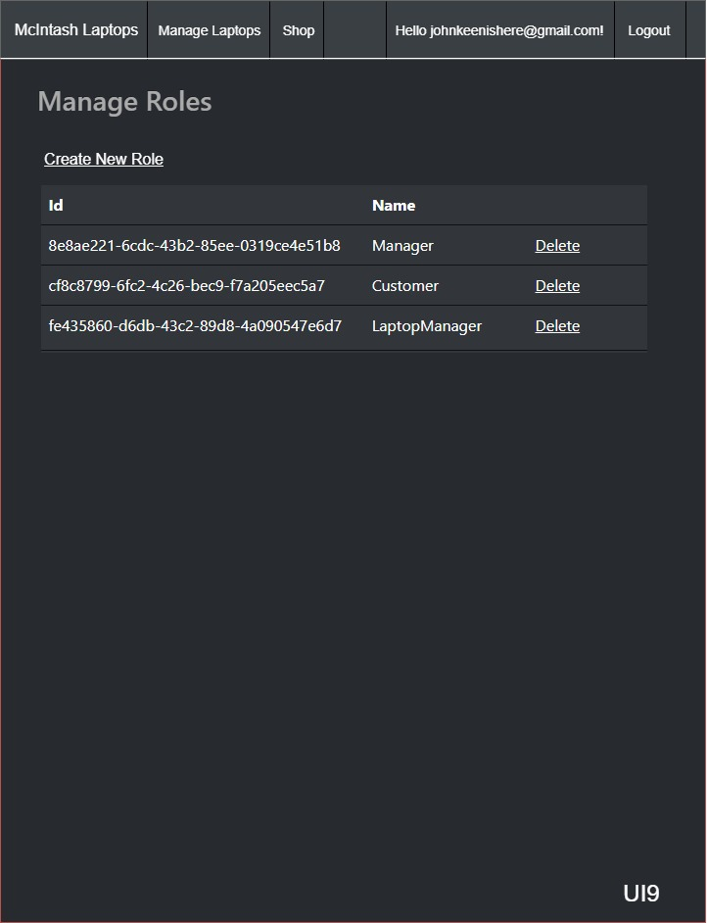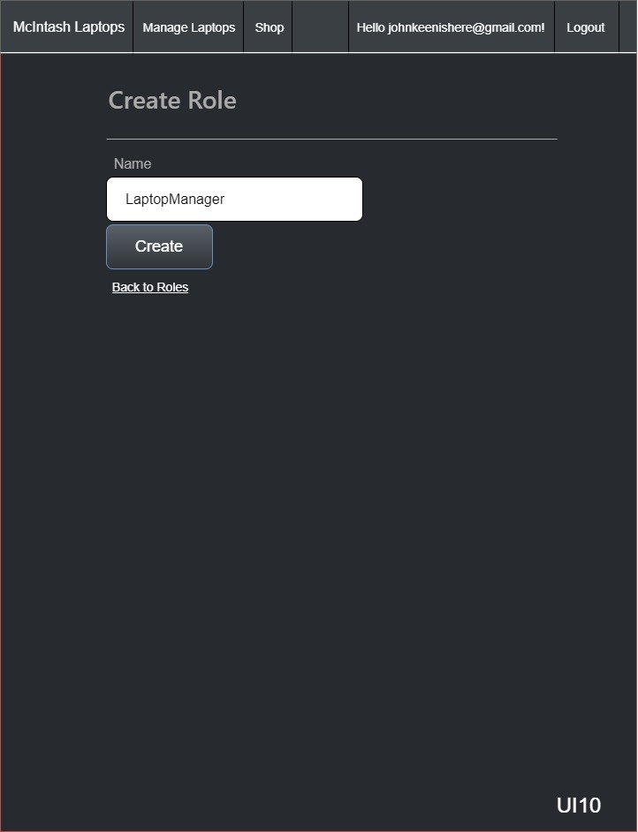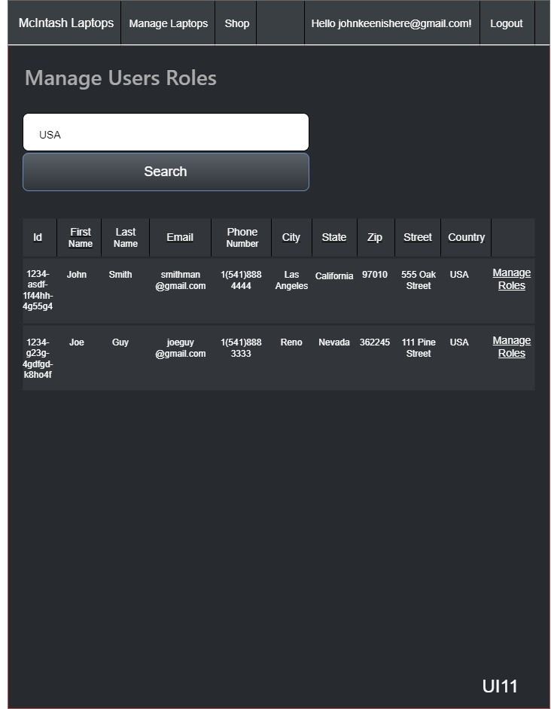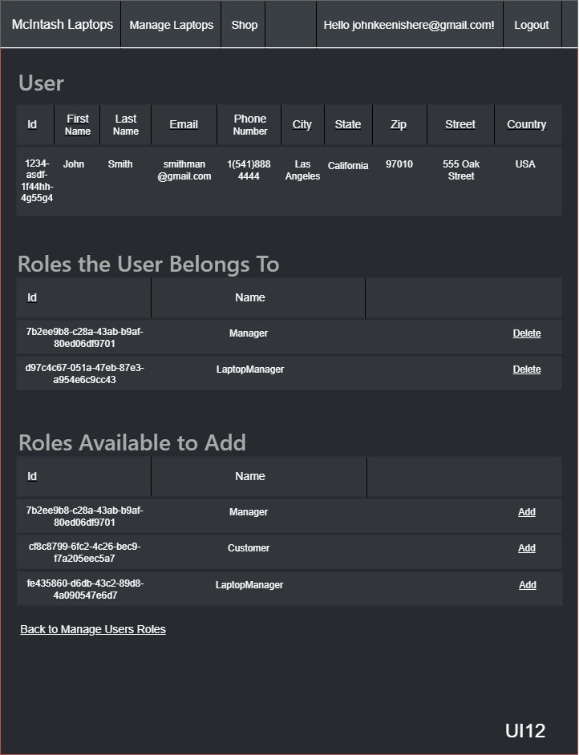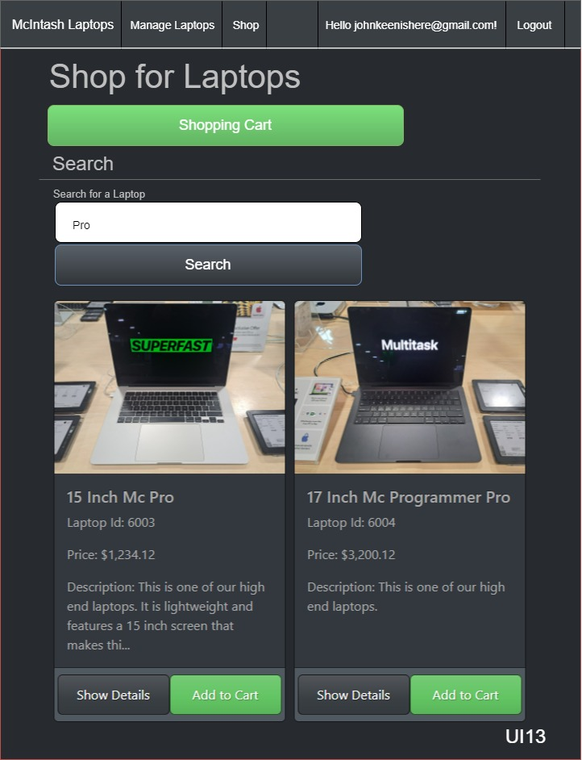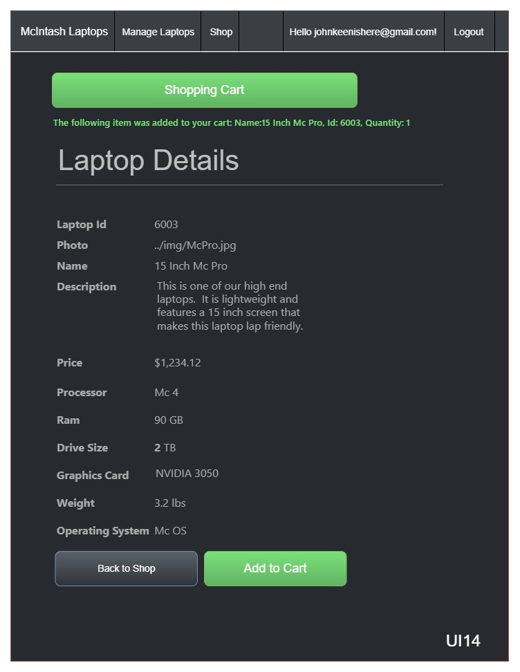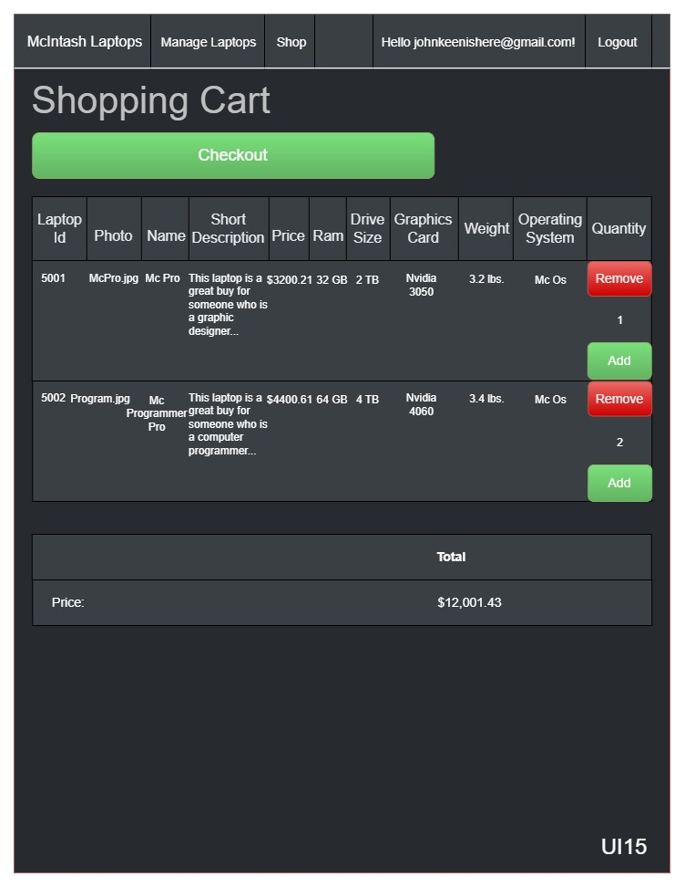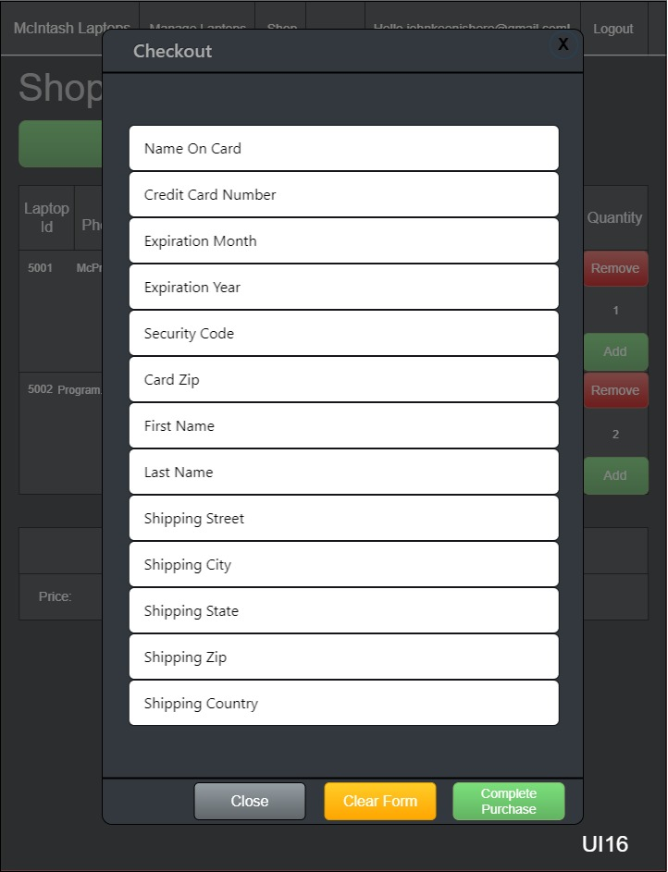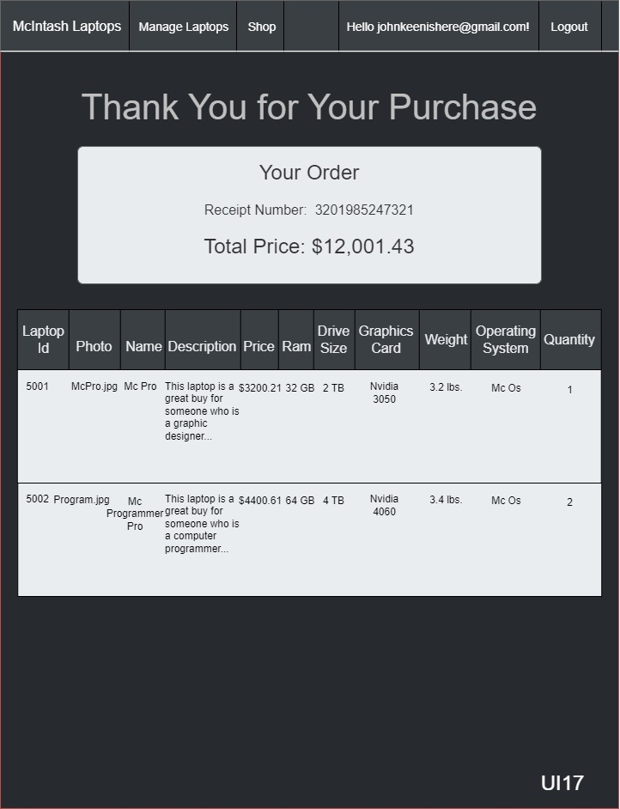

# Reports Design

The system does not produce reports. The types of data that are generated is outlined in the wireframes. The web application will allow Laptop Managers to Create, Read, Update and Delete laptop records that are saved in a table in an MSSQL database. This data is available by means of a REST API. Anyone with an account can navigate to the Shop area and add an item to the cart and then checkout which will render a receipt. This is where I trim the tail on the project. The system logical model in this document provides a visualization of the flow of information in this web application. It is a good visualization of the processes that are occurring.

A potential report in future versions of this web application could include an order or shipping status report of a customer’s laptop(s).

# Security

The concept for this project started as a simple catalog for a laptop manufacturer. It would need security to ensure that nobody maliciously changes the laptop records such as the price of a laptop. A compromise in security could cause a catastrophic loss of money or reputation. The information in the catalog is available to retailers by means of a REST API which has a few endpoints for returning various laptop information. For security reasons, there will not be endpoints for creating, updating or deleting laptop records. For this reason, there will not be a need to authenticate the REST API but if a problem with denial-of-service attacks arises then rate limiting software may be leveraged to ensure that each IP Address is limited to a reasonable amount of traffic. The laptop catalog management area of the site will be protected by the Microsoft Identity Framework which will use roles to ensure that only authenticated and authorized personnel can use the laptop CRUD functionality of the site. Only users with an account will be able to make a purchase in the shopping area of the web application.

The shopping area will have concerns about security regarding the handling of a user’s vital information. The information will need to be encrypted in transit using TLS. A payment gateway will be used to process a payment but only the last four digits of a credit card will be saved to the companies database to ensure that the site passes PCI DSS compliance. The last four digits of the credit card number will be encrypted at rest using Microsoft’s IDataProtectionProvider. The fact that the user has to be logged in to the site in order to access the shopping area or place a purchase will help protect the site from malicious automated scripts and help track malicious activity. The most vital information saved on our site at checkout will be the users purchase information, shipping address and the last four of the user’s credit card number. There may be various reasons why an attacker may want this information but the information in itself will not be enough to compromise the identity of the users. The primary concern being that if an attacker procures a shipping address, then they can use Phishing to coax customers out of information that is vital to their identity. Passing inputs to the database as parameters will help protect the database where the shipping information is stored.

